Title: Applying Agentive AI for Anomaly Detection and Inference of Asset Misappropriation by QuickBooks Users
Author: Ronald C. Turner Ph.D., Consultant
Submitted to: Journal of Forensic Accounting
ABSTRACT

ORIGINAL:
Next-Generation Audit Management Environment (NGAME) aims to mitigate misappropriation of assets by a QuickBooks Online (QBO) user in a small organization. It targets two members of the organization: (1) the bookkeeper and (2) the financially responsible person (FRP). NGAME exploits AI large language models (LLMs), W3C's Web Ontology Language (OWL) and statistics (an adaptation of Phi Correlation) to monitor the bookkeeper’s activity. It reduces “warning fatigue” by emitting only meaningful and actionable alerts. Autonomous agents direct the workflow: (1) training to learn the bookkeeper’s normal “churn" (day-to-day QuickBooks activity); (2) detecting anomalous activity; (3) deciding whether that activity might indicate misappropriation of assets; then (4) alerting the FRP only if the activity is noticeable (FYI only), remarkable (worth inspection) or actionable (requiring immediate intervention). A software prototype has successfully demonstrated the workflow described above. The paper is a functional description of NGAME as an open-source (freely available) software product.

REVISED:
Small organizations do not have the resources for internal controls to exercise continuous proactive surveillance. Next-Generation Accounting Monitoring Engine (NGAME) aims to mitigate misappropriation of assets by a QuickBooks Online (QBO) user in a small-to-medium enterprise (SME). NGAME exploits an AI stack—agent-orchestrated pipeline, retrieval augmented generation (RAG) and generative AI supported by a large language model.(LLM). It relies on the Web Ontology Language (OWL) to support a granular and persistent semantic description of the organization’s ledger. To measure the “churn” of a day’s journal activity—a central innovation of this paper—NGAME applies the Jaccard statistical method to derive a “churn persistence index (CPI).” NGAME’s primary benefit is to prevent “warning fatigue” by emitting only meaningful and actionable alerts to the FRP. It does so by (1) training the engine to learn the organization’s normal “churn”, (2) detecting anomalous activity; (3) deciding whether that activity might indicate misappropriation of assets; then (4) alerting the FRP only if the activity is noticeable (FYI only), remarkable (worth inspection) or actionable (requiring immediate intervention). NGAME’s deployment in a multi-site national charity has demonstrated the success of the innovative approach and design described in this study and of its feasibility as an open-source (freely available) software product.

I. INTRODUCTION
Motivation for the Project

NGAME responds to a perceived need among small organizations, non-profits in particular. Cases of a bookkeeper’s asset misappropriation most frequently go unreported in order to protect the organization’s image among its donors. But whenever a case is reported and prosecuted, the story is familiar:

[The bookkeeper] made unauthorized electronic transfers and debit card purchases for personal use, including paying her mortgage, utilities, and property taxes. . . To hide her actions, [she] made false entries in the organization's [Meals on Wheels’] internal accounting system, making the personal expenses appear as legitimate operating costs. . . .The embezzlement rattled the organization, affecting morale among employees and volunteers and scaring away some donors. (U.S. Attorney’s Office 2019)
The factors contributing to this scenario invariably include the following:
- Inability of best practices alone to deter misappropriation of assets (internal fraud), particularly among small non-profit organizations.
- Intractability of detecting nefarious intent. Even with sophisticated technologies, it is difficult to detect a bookkeeper’s lapse into the state of rationalization, desperation or greed that would result in asset misappropriation,
- Non-existence of right-sized digital tools for the FRP to detect and deter likely fraud proactively and effectively.
- Warning fatigue: pervasive “attention disorder” of the FRP, provoked by false negatives, rendering him/her progressively less inclined to respond to warnings, whether from widely accepted best practices or from paranoid machines.
- Product Limitation. The QBO Audit Log—the FRP’s and auditor’s most reliable source of user activity—provides a textual description of accounting events, but no developer API endpoints to the Log, no alerts to anomalous events, no means of detecting nefarious activity, and data export consisting only of a largely text-only spreadsheet.
- Misaligned improvement. Intuit has announced “Intuit Intelligence, a revolutionary system of intelligence that provides businesses and accounting firms with everything they need to compete and grow in the AI era.” The announcement includes anomaly detection, the feature of greatest interest for this study: “IMPROVED! Accounting Agent: Expanded anomaly detection,” Intuit Intelligence signals anomalies by flagging suspicious items in reports, not in the Audit Log. This assumes that the bookkeeper generates reports regularly and that the FRP reads those reports faithfully. In practice, this product upgrade is beyond the reach of a small organizations that use QBO for basic accounting and creates reports only as needed.
Approach

Architecture.

NGAME is a hybrid system, consisting of two pipelines, both executed autonomously by agents. One is a traditional data engineering pipeline, the other an AI pipeline that exploits and augments a freely-available local LLM. The first performs Training, which configures the system from scratch, its agents ingesting and analyzing the bookkeeper’s behavior over the training period. The output of the Training pipeline is a stored baseline against which the system will analyze each day’s activity.

The second pipeline performs daily anomaly detection and fraud analysis. Its agents execute this workflow daily, each day examining the QBO user’s work activity, watching for any meaningfully unusual (anomalous) patterns. When the agents detect an anomalous pattern, they present their findings, together with a taxonomy of asset misappropriation to the LLM. The LLM returns appropriately-scaled warnings for the FRP to read.

Definition of NGAME

This report highlights three aspects of the NGAME project:

- AI-driven audit tool. The NGAME app—currently deployed at a multi-site 501(3)(c) national organization—exploits agentive AI as the backbone technology for a readily-accessible, low-maintenance forensic tool:
(a) Detects anomalous activity by a QBO user, then
(b) Determines whether that activity signals a possible misappropriation of assets, and then
(c) Decides whether to report the event to the FRP as notable (“fishy”), remarkable (“worth your taking a look”) or actionable (“you’d better get on this!”).

- Specialized arbiter. NGAME focuses exclusively on asset misappropriation, an authoritatively defined region of the fraud taxonomy depicted in Figure 1 (Association of Certified Fraud Examiners, Inc. 2024).

- Freely available software. NGAME (the product) is an open-source QBO companion app, a forensic audit solution for small non-profits, released under terms of the Apache Foundation to be downloaded (cloned) onto the FRP’s computer.

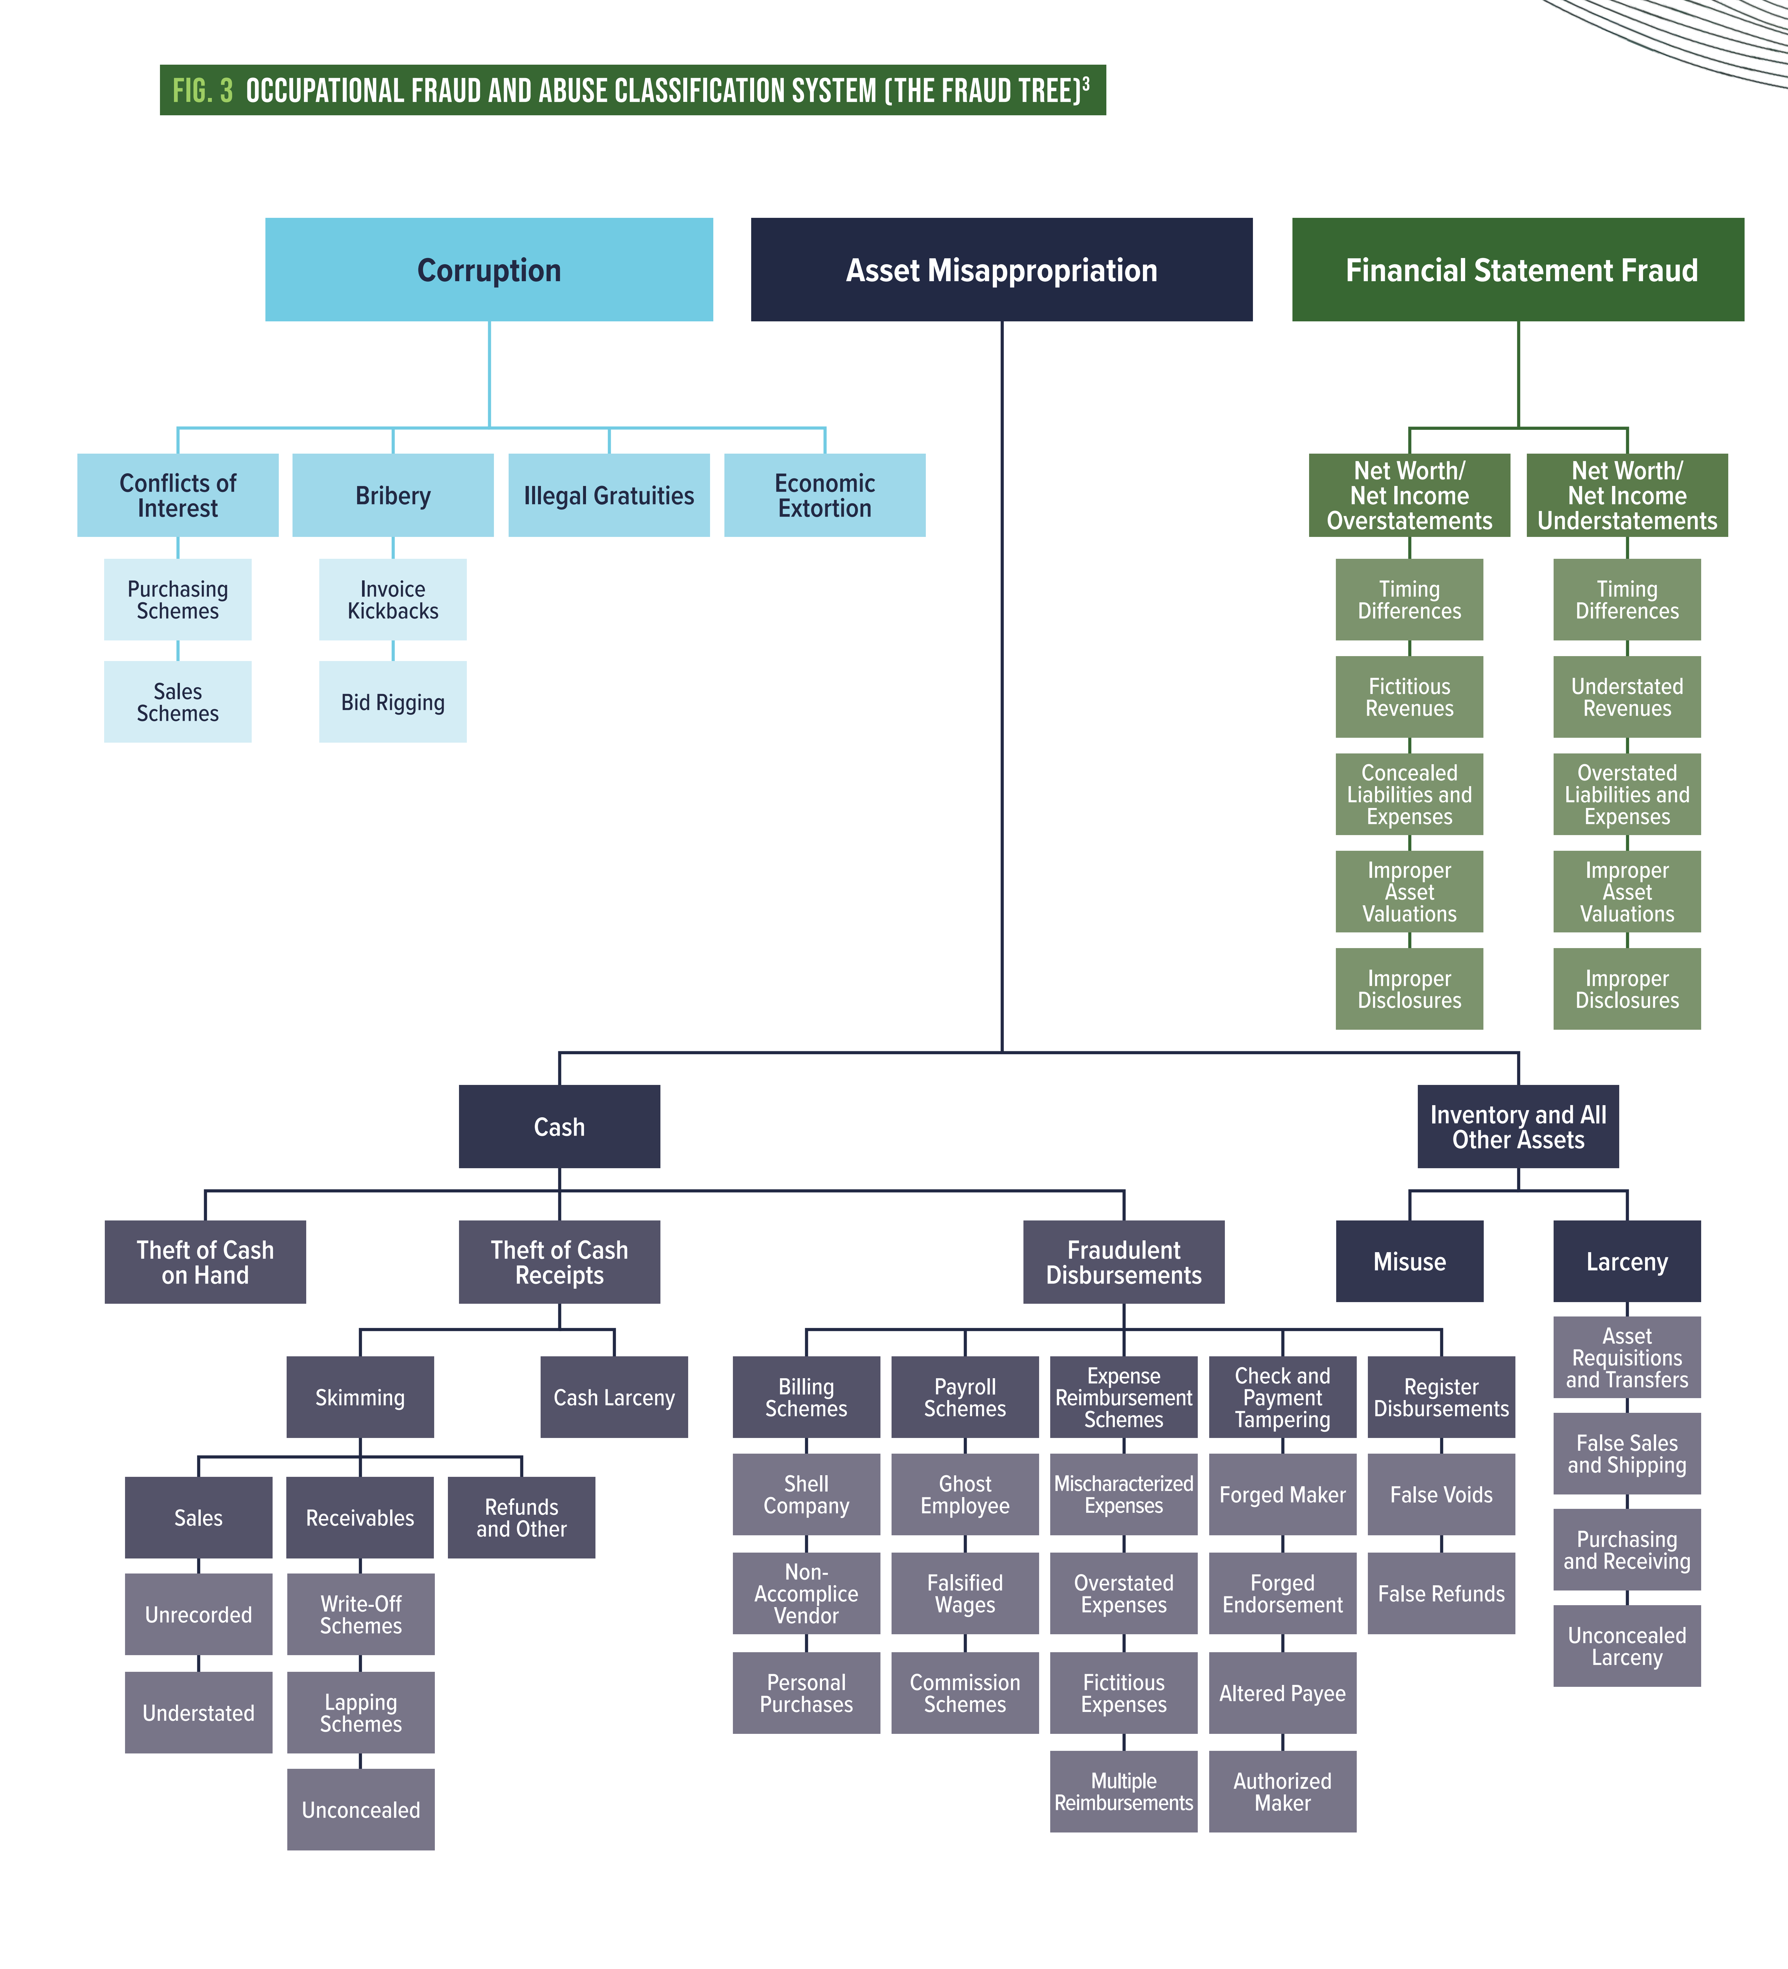
Figure 1. Occupational Fraud and Abuse Classification System (the Fraud Tree). pdf

uniqueness in the stream of existing research

The NGAME project is consistent with the general direction of current research and commercial solutions. However, certain innovative features constitute advantages over existing solutions, each advantage delivering a benefit for the audit community):

- Index of “Daily Churn,” a purely statistical—not semantic—measure of the bookkeeper’s behavior, quantifies immediately the current day’s level of conformance with or deviation from normal (daily) QBO activity. Existing anomaly detection schemes rely on retained historical data, which must reach over several sessions or states of the accounting system. Those solutions are therefore architecturally stateful. NGAME’s churn relies only on the organization’s training data—a tiny static matrix—plus its snapshot of the previous day’s activity. NGAME is thus a nearly stateless engine.

Benefit: NGAME’s near-stateless architecture results in drastically reduced “data maintenance debt. It thus enables NGAME to require the smallest and most stable possible data footprint on the surveillance computer.

- NGAME’s fraud detection segment (1) ingests perceived anomalies in the day’s bookkeeping activity, (2) reasons with those anomalies in relation to the semantics underlying a taxonomy of asset misappropriation, then, only if the anomaly is genuinely suspicious, (3) calculates an appropriate level of response and (4) notifies the FRP with a colored signal on the NGAME Dashboard. I.E. the FRP single-clicks once a day to see only the anomalies that matter.

Benefit: Near-continuous audit requiring only the FRP’s single click.

3. RDF (Resource Definition Framework), represented with Terse RDF Triple Language (ttl, pronounced “turtle)), expresses the subject-predicate-object elements of a knowledge map. NGAME creates and relies on Web Ontology Language (OWL) turtle (.ttl) files throughout for expressing knowledge. Terse by definition, an OWL .ttl file exerts minimal storage and execution requirements. OWL as an international standard (W3C Recommendation) generates NGAME knowledge data that is portable, visible, explainable and capable of reasoning.

Benefit. Turtle files enable lossless semantics, plus minimal-cost, trustworthy access to every accessible detail of the user’s activity,

4. Ontology-based retrieval-augmented generation (RAG) enables just-in-time customization, plus reconciliation with local rule sets.

Benefit: NGAME agent performs site-specific “supervised training” of the LLM; zero-cost human effort for model customization.

5. Explainability. Autonomous agents detect anomalous activity within QBO, then infer and report possible nefarious activity.

Benefit: Instant warning (i.e. nearly continuous audit) for the organization’s FRP(s) and auditors, reducing or eliminating manual searches of audit and machine logs.

6. Numerous AI-driven agents execute the major operations and sub-operations of NGAME

Benefit: The organization’s management, account(s) and auditors are relieved of the burden of manually performing a repetitive and costly workflow of anomaly detection and fraud analysis.,

7. Accessibility and feasibility: Freely-available LLM resides on local machine (Ollama, one of 700,000+ LLMs).

Benefit: Zero-subscription cost and zero-public-exposure AI.

II. RIGHT-FITTING AI

NGAME’s two-fold contribution to preemptive audit in a SNPO is that it (1) detects anomalies at the QBO Transaction Type level in the bookkeeper’s actual current activity, then (2) trains the AI model on-the-fly to match those noteworthy transaction types with particular types of asset misappropriation. This precision of anomaly detection, in conjunction with an accurate match-up with fraud types, equips NGAME with the precision it needs for issuing management-level warnings that are both concise and accurate. This is NGAME’s contribution to overcoming “warning fatigue.”

The project furthermore demonstrates that an AI LLM—of itself and without a carefully tailored architecture—is incapable of delivering a solution of true value. The following discussion is an account of the tailoring required for AI to function in an effective manner.

Tailoring the LLM

A well-trained LLM—on its own, without any further training—is fully capable of ingesting a natural language prompt referring to any topic, reasoning over the prompt, then emitting a credible human-like response. But the widely-recognized problem with LLM is that its response is often loquacious to point of hallucinatory. For example, following is a prompt to Ollama2 (the freely-available LLM used in this project) and the model’s lengthy response:

Prompt to Ollama:
>>The bookkeeper has added an unusually large number of vendors today. Is this a sign of asset misappropriation?

Unassisted (no further training) Response from Ollama:
It is possible that the addition of an unusually large number of vendors could be a sign of asset
misappropriation, but there are other potential explanations as well. Here are some factors to
consider:

1. Increased transactions: If the bookkeeper has added a large number of vendors, it could
indicate that there is a higher volume of transactions occurring in the business. This could be a
normal part of growth or an indication of asset misappropriation if the additional vendors are
not legitimate.

2. Unusual payment patterns: If the bookkeeper has added vendors without proper authorization or
documentation, it could indicate that assets are being misappropriated. For example, if the
bookkeeper is making large payments to these new vendors without proper documentation or approval from management; it could be a sign of asset misappropriation.

3. Discrepancies in financial records: . . ..

4. Lack of transparency: . . . .

5. Internal controls: . . . .

It is important to note that these are just potential indicators of asset misappropriation, and
further investigation is needed to determine whether or not asset misappropriation has occurred.
If you suspect that asset misappropriation may be occurring in your business, it is important to
consult with a qualified fraud examiner or forensic accountant to conduct a thorough
investigation.

The problem with the LLM’s response is that, while not hallucinatory, it is highly context-insensitive. The question—generated by the anomaly detector—was simple, anticipating a yes-no answer. Instead, the unconstrained model has used its learning to reach far afield to generate a comprehensive 316-word report. This response, though fact-based and highly authoritative, is useless to a busy FRP in a small non-profit. In human factors terms, the response has the effect on the FRP of a diffuse false positive.

Retrieval-Augmented Generation (RAG) As LLM Constraint

In this study “fraud”—an extraordinarily broad term—is narrowly defined as “misappropriation of assets,” the fraud most likely committed by an errant bookkeeper in a small organization. The most AI-driven segment of the architecture must reason whether anomalous activity in certain ledger accounts reliably signals nefarious behavior by the bookkeeper. In order to augment the LLM’s situational awareness, the Fraud Detection Agent performs an “on-the-fly” enrichment training of the LLM in two ways: (1) by serving up a predefined, authoritative structured definition of asset misappropriation (middle segment of tree in Figure 1) and (2) by adding a snapshot of the ledger, as modified by the bookkeeper. The access misappropriation taxonomy depicted in Figure 1 appears in Figure 2 as a .ttl file as rendered by OWL. Figure 3 depicts the ledger snapshot as OWL. The ontology describes 36 Transaction Types, within which the QBO user works during each day’s session.

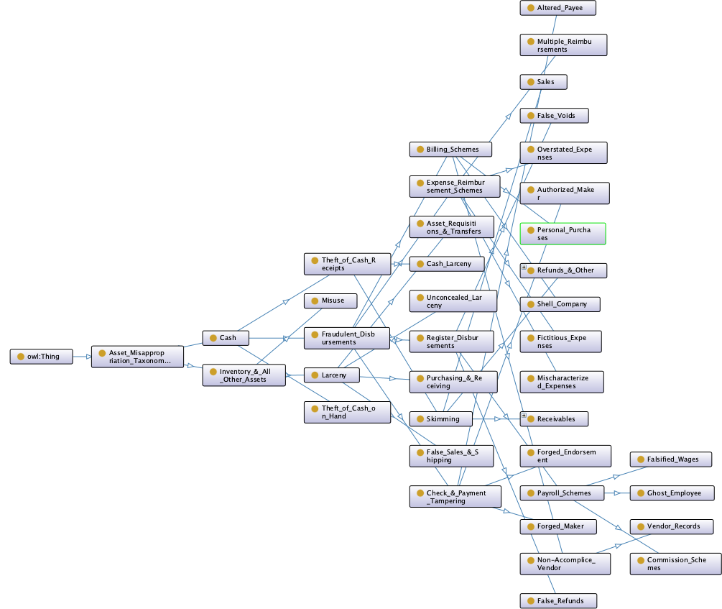
Figure 2. Asset Misappropriation Taxonomy as OWL

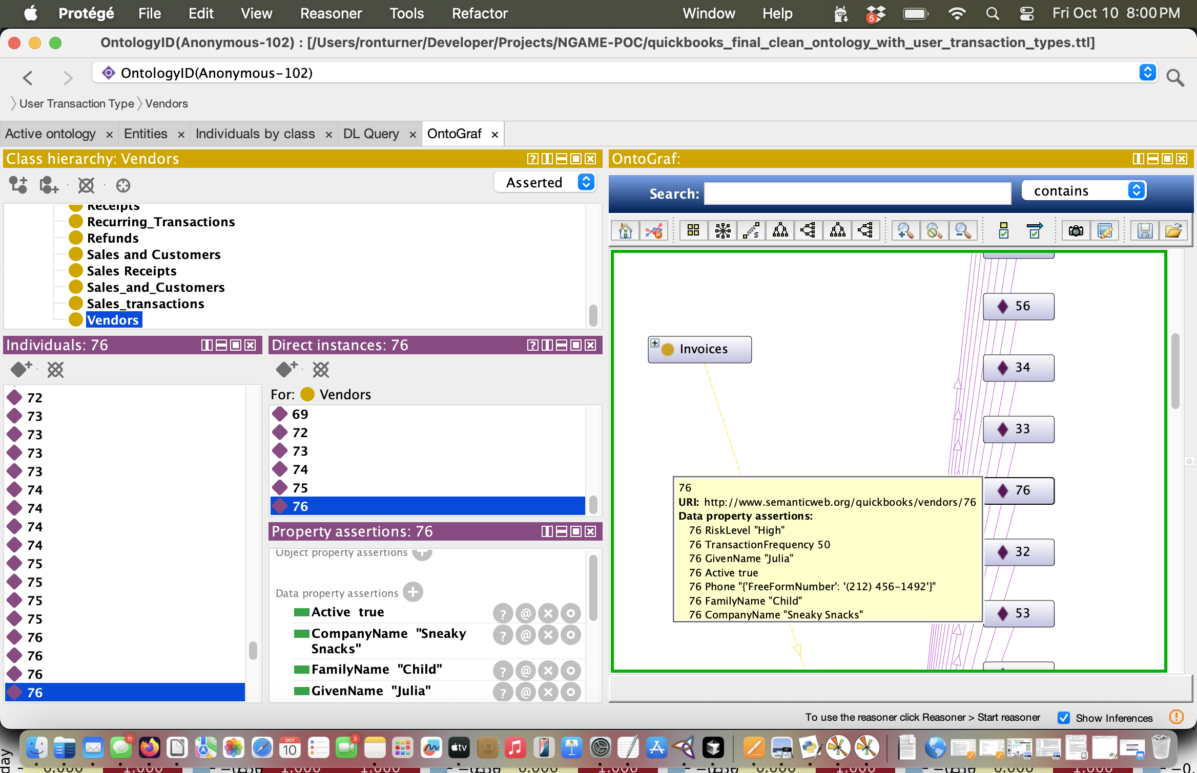
Figure 3. OWL Representation of the Current Day’s Ledger

In order for a resource to qualify as a legitimate RAG augmentation, it must present to the LLM as retrievable data. NGAME’s Fraud Detection Agent provides this retrievability by presenting the asset misappropriation sub-tree to the LLM as a W3C standard Web Ontology Language (OWL) file, depicted in Figure 2. In like manner, the agent presents the day’s ledger to the LLM as OWL. The agent’s OWL-augmented prompt to the LLM clearly qualifies NGAME as a legitimate RAG implementation. Thus enriched by the agent’s augmented prompt, the LLM can refine and augment its retrieval and reasoning

Exploitation of AI Agents

In NGAME there are eight agents plus two managers to oversee their respective agents. The section “How NGAME Works” below will describe these agent-directed activities. Figure 4 depicts the high-level agentive architecture.
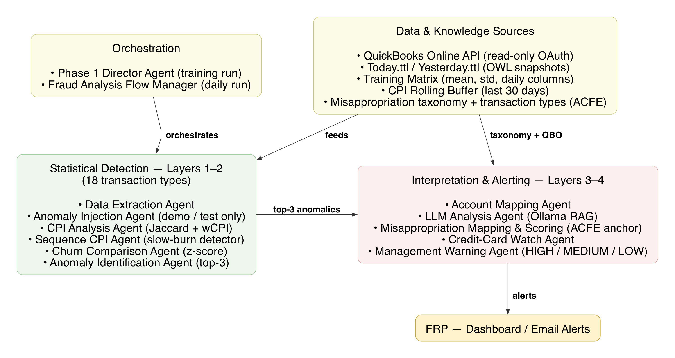

Figure 4. NGAME Agent Interaction Network

NGAME exploits agentive AI. Agents enable NGAME to operate autonomously, initiating appropriate activity based on ever-changing status among large quantities of complex data. From an AI standpoint, agent-directed NGAME is a hybrid implementation. Agents driving its earlier workflows (e.g. system training, acquainting the system with the bookkeeper’s normal daily activity), though autonomous, are rule-driven, based on statistics. These agents therefore do not support NGAME’s claim as “agentic AI.” But as the annotated flow diagrams describe below, the majority of agentic activity is (1) defined in real time by dynamic data, (2) is adaptive to live input, and (3) responsive and constantly refocused based on dynamically created data.

III. TECHNICAL DESCRIPTION

At the highest level of abstraction, NGAME (1) familiarizes itself with the bookkeeper’s normal daily mix of activity within QBO’s Transaction Types, (2) detects a day when that activity is unusual (i.e. the Transaction mix is not normal), (3) analyzes the bookkeeper’s anomalous behavior to decide whether it signals possible nefarious activity by the bookkeeper, then (4) alerts the FRP(s) at the appropriate level to possible fraud

Two pipelines of activity support NGAME’s capability to mitigate asset misappropriation: (1) training, performed only at system initialization, then only occasionally at the discretion of the organization; and (2) daily anomaly detection and fraud analysis

System Training

The user organization must first acquaint NGAME with the bookkeeper’s normal day-to-day activity. This training activity results in a numerical profile, a stored baseline against which to test for anomalous activity by the bookkeeper. The baseline is called a “matrix” in the architecture and is represented by an m x n spreadsheet where each m is a row designating a QBO Transaction Type (e.g. Vendors, Bills, Receipts). Columns 2-n contain numerical values, to be explained later. (In a QBO installation for non-profits, the “Customers” Transaction Type should appear as “Donor.”) The local organization determines the number of days’ training required to represent the bookkeeper’s typical daily activity. Figure 5 is an example of a matrix that has been in training for three consecutive days.

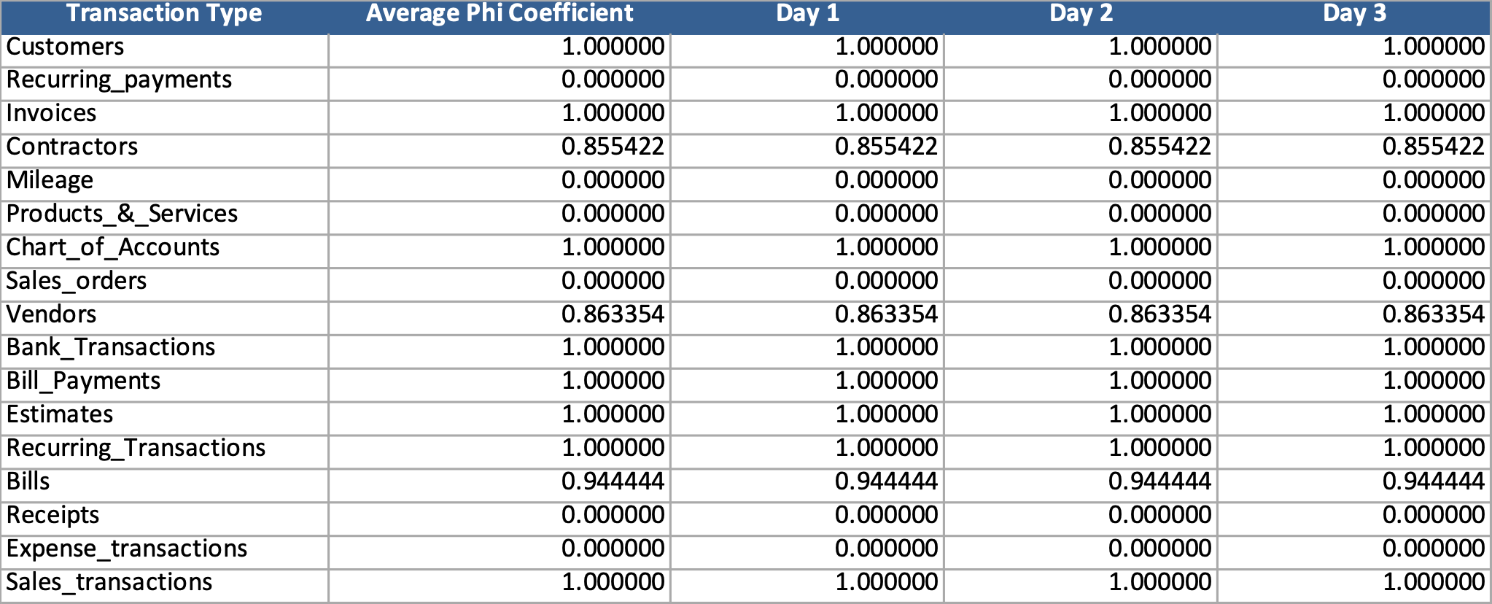
Figure 5. Training Agent Matrix

Following is a step-wise description of the Supervised Learning process:

- NFP management determines the number of workdays required to capture a full and accurate profile of the bookkeeper’s normal QuickBooks activity.
- The bookkeeper performs business activity that (1) is normal for the organization, (2) exercises every applicable functionality of QuickBooks and (3) touches every applicable item in the organization’s chart of accounts.
- Each day the training agent, the agent inspects each item in the QuickBooks ledger, detecting whether the bookkeeper has modified that item (e.g. changed an invoiced amount). The agent calculates a measure of change within the corresponding QBO transaction type.
- At the end of the training period the training agent derives a coefficient expressing the per-day change within each transaction type.
- The agent clusters the transaction-level coefficients, retaining the cluster as the bookkeeper’s churn coefficient, his/her unique descriptor (“fingerprint”) of normal QuickBooks activity. This cluster constitutes the reference set of item change coefficients. This reference set functions as the baseline against which each day’s churn is compared.
- The stored cluster of coefficients persists for as long as (1) the organization’s activity remains generally as it was during the training period and (2) until the chart of accounts is modified. A change in either the activity or the chart of accounts requires a new training process.
The following multi-page flow diagram depicts the Training Pipeline, which builds the matrix shown in Figure 5. Column 2 of the matrix is a numerical index denoting “normal bookkeeper activity for each QBO Transaction Type. At the end of the training period, the matrix is retained as the baseline against which to compare each day’s activity by the bookkeeper within each QBO transaction type.
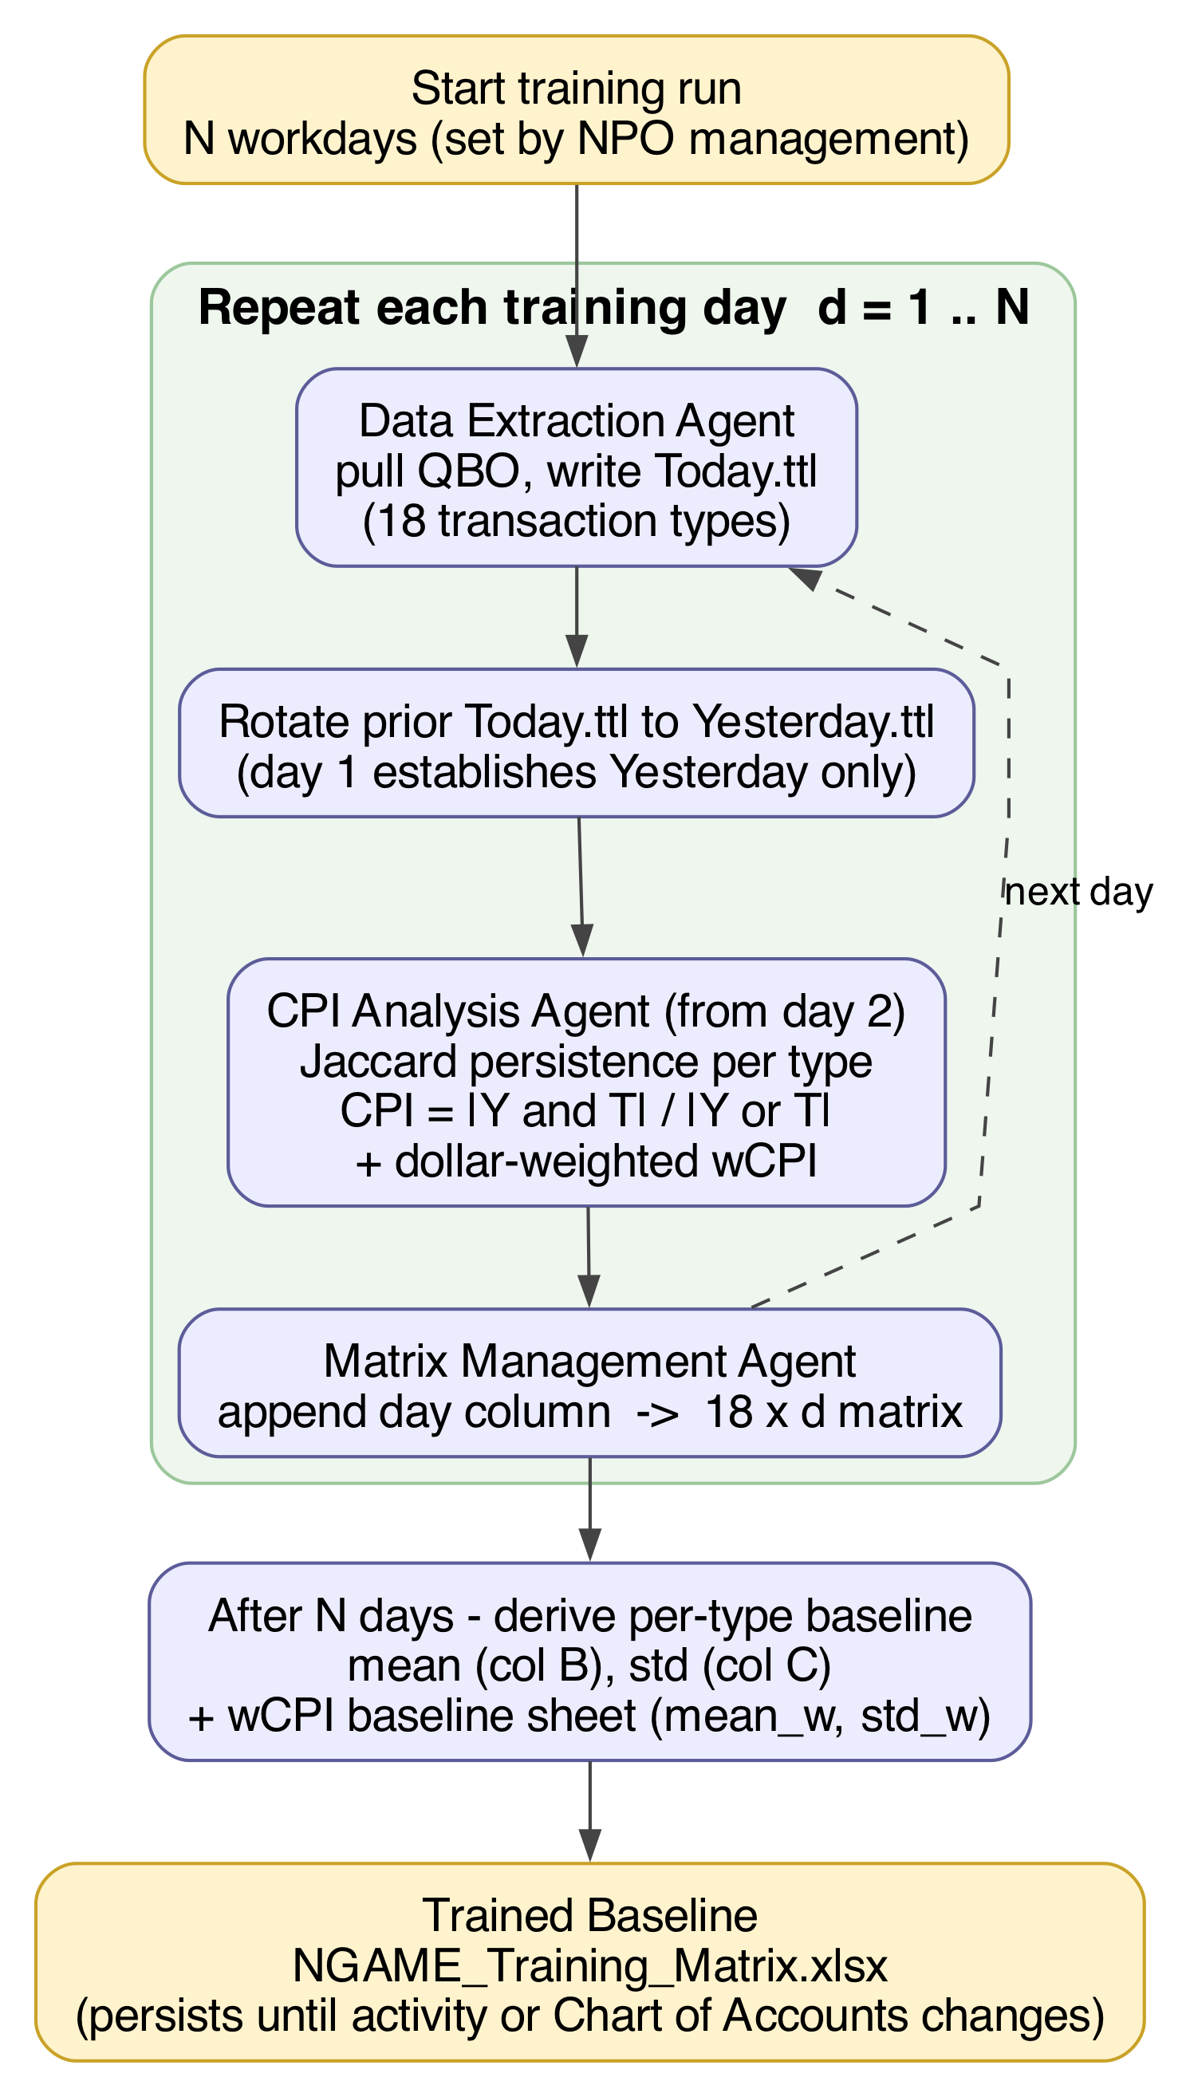
Figure 6. NGAME Training Flow

Daily anomaly detection and fraud analysis

Following is a step-wise description of the anomaly detection process:

- The NFP management specifies the periodicity of analysis (i.e. how often to test for fraud), which may be a day, a week or a series of days or weeks.
- At the close of each analysis period (and with the bookkeeper signed out of QuickBooks), the fraud detection agent inspects each item in the QuickBooks ledger, detecting whether the bookkeeper has modified that item (e.g. changed an invoiced amount). The agent calculates a measure of change within the corresponding QBO transaction type for the current analysis period.
- The anomaly detection agent derives an AP-level change coefficient to each pair of changed transaction types.
- For each pair of changed items the agent compares the item’s AP-level change coefficient with its corresponding value in the reference set.
- If the AP-level coefficient exceeds the value of its counterpart in the reference set, the agent decides whether the elevated value for a particular item should be declared a legitimate anomaly. For example, an activity period with bulk changes of address are clerical/textual and would not qualify as anomalous. Excessive changes to the vendor list or a modification to the chart of accounts or are semantically rich and should be flagged as anomalous.
Figure 7. NGAME Daily Fraud Analysis
Panel A: Detection and triage (Layers 1–2).
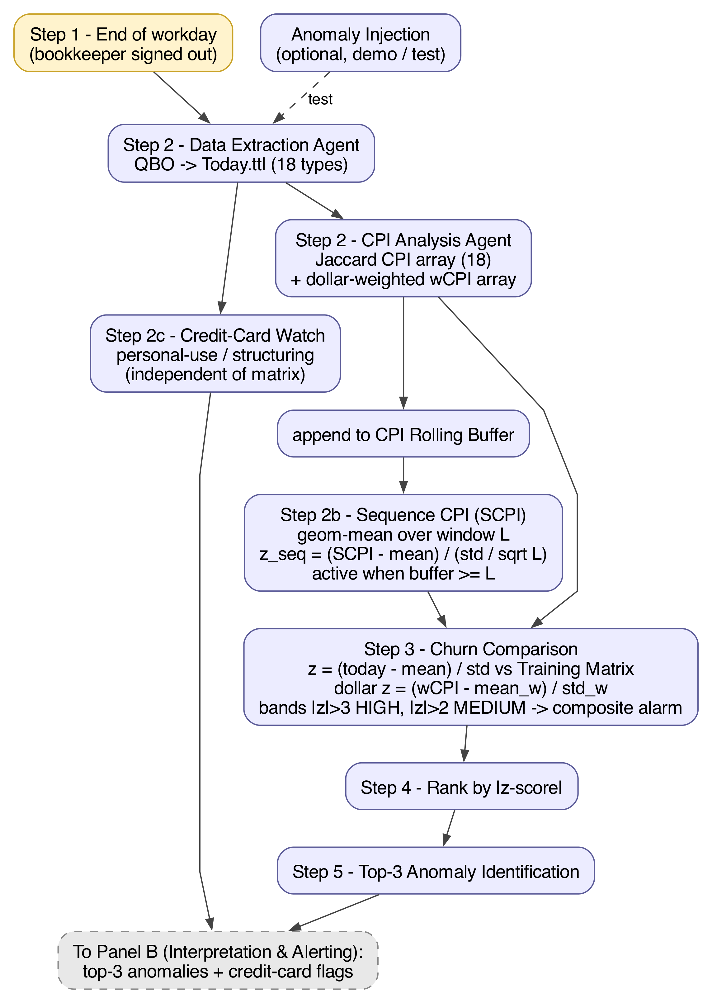
Panel B: Interpretation and alerting (Layers 3–4).
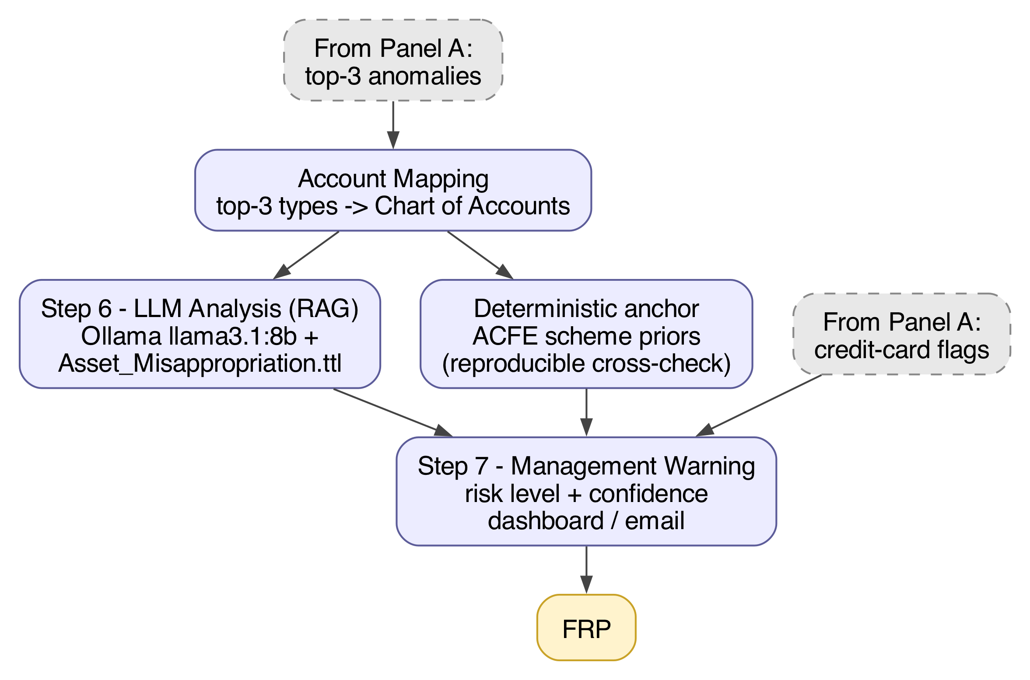

Phi Correlation Coefficient REPLACE entire section to match Jaccard-based measure.

This study adapts the Phi Correlation Coefficient in order to measure the deviation of the current day’s activity against the baseline values stored in the Matrix. First, a brief review of the “standard” Phi. (geeksforgeeks.org 2025)

The standard Phi formula measures correlation among binary (yes/no) data. The results of a study of the relation between smoking and lung cancer are organized as a 2x2 contingency table:

 | Lung Cancer | No Lung Cancer | Total
Smoker | 30 | 20 | 50
Non-smoker | 10 | 40 | 50
Total | 40 | 60 | 100

The underlying 2x2 contingency table for the with yes/no coordinates in both the x and y columns: Smoker? Lung Cancer?

 | X = yes | X = no
Y = yes | A | B
Y= no | C | D

The values of A, B, C, and D are inserted into the following formula for calculating the phi coefficient. The result describes the relationship between smoking and cancer in statistical terms:
$$ϕ=\frac{\left(ad−bc\right)}{\sqrt{\left(\left(a+b\right)\left(c+d\right)\left(a+c\right)\left(b+d\right)\right)}}$$
With the values from the contingency table above, $ϕ$ = 0.408, which indicates a moderate positive association between smoking status and lung cancer.
NGAME, on the other hand, requires a measure of correlation between sets of non-binary values. For NGAME it is necessary to compare not binary (yes/no) data but to describe the correlation of sets of numeric and text data between the baseline (stored in the Matrix during the Training period) and the current day. The following example measures the impact of a bookkeeper’s adding an anomalous number of vendors to the ledger in a single day.

Yesterday there were ten vendors in the ledger. Today the bookkeeper added six more:

Yesterday (Set 1): {V1, V2, V3, V4, V5, V6, V7, V8, V9, V10}
Today (Set 2): {V1, V2, V3, V4, V5, V6, V7, V8, V9, V10, V11, V12, V13, V14, V15, V16}

The modified (set-comparison) Phi measure first requires three variables:

Variable | Meaning | Value
Shared | Count of vendors in BOTH yesterday and today | 26
Total Items | Total count: len(set1) + len(set2) | 26
Overlap Ratio* | The computed ratio before final phi conversion | ≈ 0.769

* The overlap ratio is computed as follows:
overlap_ratio = (2 * |Set 1|) / |Shared| = 2 * 10 / 26 ≈ 0.769

The value of the overlap ratio (0.769) is a factor in the Phi formula for set comparison:

φ = 2 * 0.769 - 1 ≈ 0.538

Here is a plain-English explanation of the Phi formula, as modified for set comparison:

Phi Value | Plain English Meaning
φ = +1.0 | Perfect identity — Yesterday and Today have EXACTLY the same vendors. No change whatsoever
φ = 0.0 | Moderate change — 50% of the vendors are the same, 50% are different. Half the set changed
φ = -1.0 | Complete dissimilarity — Yesterday and Today have NO vendors in common. Completely different sets
φ between 0 and +1 | Complete dissimilarity — Yesterday and Today have NO vendors in common. Completely different sets
φ between -1 and 0 | Significant dissimilarity — Most of the set changed. Major differences between sets

Meaning of the Phi result: "The vendor set is substantially similar (φ ≈ +0.54), but with notable additions. About 77% overlap between yesterday and today."

The set-comparison Phi used in this study compares with the classical Phi coefficient as follows:
- Classical Phi measures association in a 2×2 contingency table
- Modified Phi measures set similarity directly without requiring a contingency table
- Both return values in the range [-1, +1]
- Both measure the strength of relationship/association

Executive-Level Warning

At the close of the day in which the bookkeeper entered an unusually large number of new vendors, NGAME’s Management Warning Agent generated the following advisory, quoted verbatim. It is based on (1) the bookkeeper’s work, judged that day to be anomalous activity and (2) reasoning by the LLM, augmented by the Asset Misappropriation Taxonomy:

Based on the data provided, I have identified several potential misappropriation patterns involving various accounts. The highest-risk patterns involve creating fake vendor invoices or manipulating existing ones to obtain unauthorized funds or assets. These patterns are assessed as “High” or “Critical” risk levels, with confidence levels ranging from 60% to 80%.

To address these risks, I recommend the following actions:
- Review vendor invoices and payments for any discrepancies, inconsistencies, or unusual activity.
- Investigate any red flags or indicators of misappropriation, such as unexplained changes in vendor invoice amounts or dates.
- Ensure that all transactions are properly authorized and documented, and that proper internal controls are in place to prevent manipulation or fraudulent activity.
- Provide training and awareness programs for employees to recognize and report any suspicious activity related to vendor transactions.
- Consider implementing additional security measures, such as segregation of duties or dual-control procedures, to further mitigate the risk of misappropriation.

By taking these actions, you can help reduce the risk of misappropriation involving vendor transactions and ensure that your organization's assets are protected and used appropriately.

The Alert Framework assures the least possible false negatives, therefore mitigating the FRP’s “warning fatigue:
🟢 NORMAL: High consistency (phi > 0.7) = No fraud indicators
🟡 MONITOR: Moderate inconsistency (0.5-0.7) = Watch for patterns
🟠 INVESTIGATE: Significant inconsistency (0.3-0.5) = Potential fraud risk
🔴 HIGH RISK**: Major inconsistency (< 0.3) = Immediate investigation

[Response to reviewer’s comment:
9. Insufficient analysis of error rates.
While the alert framework is well structured, the manuscript does not provide detailed evaluation of false positives, false negatives, or system robustness across edge cases.“]

Answering “But is it reliable?”
Readers will ask “Is it reliable?” at every layer. Do not answer with one global yes or no. Point to the trust property for that layer:
Layer | Reader’s question | Answer in one line
1 | Is CPI measurement trustworthy? | Same Y/T inputs yield the same CPI; descriptive, not evaluative.
2 | Does it flag the right φ dimensions? | Top-k ranking is deterministic given μ, σ; precision/recall apply under controlled evaluation.
3 | Is the scheme label / LLM narrative trustworthy? | Grounded in Asset_Misappropriation.ttl, auditable against a deterministic anchor; not a fraud verdict and not evaluated with Layer 2 IR metrics.
4 | Was the management action correct? | FRP judgment is ground truth in production; outcomes are corroborated, benign, or missed.

A central claim for NGAME’s uniqueness is that it provides reliable and actionable warnings for the FRP. It is critical to explain the basis for this general claim of “reliablity.” To do so, we offer a precise, multi-layered redefinition of “reliability” as “trust property,” based on the four stages of NGAME’s pipeline:

This glossary assigns one vocabulary per layer and directs each layer’s trust property — the kind of warrant the layer can honestly claim — without imposing a single global definition of “reliability.”

Layer | Retires or restricts
1 — Structural | TP/FP/FN/TN on the day-over-day Jaccard 2×2; use retained / added / removed / excluded
2 — Detection | Standard IR / confusion-matrix terms only in controlled evaluation against ground truth
3 — Scheme interpretation | “Triage,” “reliable ranking,” and fraud-verdict language for LLM taxonomy output
4 — FRP adjudication | Unqualified “true/false positive” and autonomous fraud verdicts

Layer Overview
Layer | Question answered | Primary outputs | Ground truth | Trust property
1 — Structural | How stable is each transaction-type population from yesterday to today? | CPI, α (addition rate), δ (deletion rate), wCPI | None required; descriptive set overlap | Reproducibility — same snapshots → same CPI
2 — Detection | Which φ dimensions deviate enough from the trained baseline to rank in the top-k alert set? | z-scores, HIGH / MEDIUM / LOW bands, top-k rankings | Injected or known anomalies (evaluation only) | Detection validity — precision/recall on dimension ranking (eval. only)
3 — Scheme interpretation | Given flagged dimensions, how plausibly do patterns align with asset-misappropriation scheme classes? | Taxonomy mappings, LLM narrative, model-reported confidence, deterministic anchor scores | Curated ontology + ACFE priors; not adjudicated fraud | Interpretive fidelity — grounded, auditable, non-authoritative
4 — FRP adjudication | What did human review conclude, and what action followed? | Corroborated / benign / missed outcomes; management warnings as briefing artifacts | FRP professional judgment after review | Adjudication outcome — operational ground truth in production
Restating “reliability” as multilayered trust properties, allows us to evaluate accurately the level of trust we can safely assume for each stage of the NGAME pipeline. In short, the architecture of NGAME allows us to move from “How reliable are the warnings?” to “What level of trust can we assume for each activity in the warning system?”
In addition, asking “How reliable….?” for a warning system incorporates the tandem question “What about false negatives and false positives?”

Development Environment

- MacBook Pro with 36 GB memory
- Cursor Pro (AI-powered Integrated Development Environment [IDE]) v. 2.0.43 from Anysphere, Inc.
- LLM: Ollama v. 0.12.6
- Subscription to Intuit Developer (API access to QBO data objects, pre-populated sandbox companies)

Generative AI and AI-Assisted Technology Statement

During the preparation of this work, the author used Cursor Pro in order to generate and then to correct, revise and document author-specified Python script. While using this tool, the author constantly reviewed and corrected the content and takes full responsibility for the content of the publication.

IV. FINDINGS AND CONCLUSIONS

- The Intuit Developer API provides everything required for a community of developers to implement, augment and support NGAME at production level. (https://developer.intuit.com/app/developer/qbo/docs/develop)
- NGAME retains only minimal statistics describing daily churn but no actual ledger data. The application therefore may be trusted to be totally non-invasive to the organization’s financial records.
- Even a statistically insignificant—but anomalous—churn (e.g. adding a few vendors to the ledger) can trigger a meaningful warning to the FRP(s).
- A freely-available, locally installable LLM (here, Ollama2) is fully capable of the reasoning required by NGAME.
- Initial pipeline execution metrics (2.76 seconds for end-to-end fraud analysis by specialized agents) and agent performance metrics (85% fraud detection accuracy) indicate the effectiveness of NGAME on a small organization’s computer.

V. PROJECT STATUS AND WAY FORWARD

- NGAME’s technical readiness level (TRL) is 3 (out of 10): a proof-of-concept demonstration of early-stage technology development plus sufficient research to prove feasibility.
- All of the accounting data for this study are currently accessible (via OAuth protocol) through Intuit’s API for developers. The system next will go live on NPOs’ computers.
- The entire codebase, plus extensive documentation in “markdown” (.md) files, are freely available from the NGAME GitHub repository. Complete details are available at https://audithentic.ai

VI. REFERENCES

Association of Certified Fraud Examiners, Inc. 2024. Occupational Fraud 2024: A Report to the Nations. Figure 3. Occupational Fraud and Abuse Classification System (The Fraud Tree)
https://www.acfe.com/-/media/files/acfe/pdfs/rttn/2024/2024-report-to-the-nations.pdf

GeeksforGeeks. 2025. How to Calculate a Phi Coefficient in R
https://www.geeksforgeeks.org/r-machine-learning/how-to-calculate-a-phi-coefficient-in-r)

United States Attorney’s Office, Eastern District of Washington. 2019. “Former Bookkeeper Sentenced to 36 Months in Federal Prison for Scheme to Embezzle in Excess of $99,000 from Greater Spokane County Meals on Wheels,”
https://www.justice.gov/usao-edwa/pr/former-bookkeeper-sentenced-36-months-federal-prison-scheme-embezzle-excess-99000

